**Vending Machine Application**

**NAVEEN KUMAR**

We have implemented basic bootstrap with JSP using spring MVC technology. When hit the url <http://localhost:8080/>SVMSpringMVC-1.0-SNAPSHOT/ getting the below screen

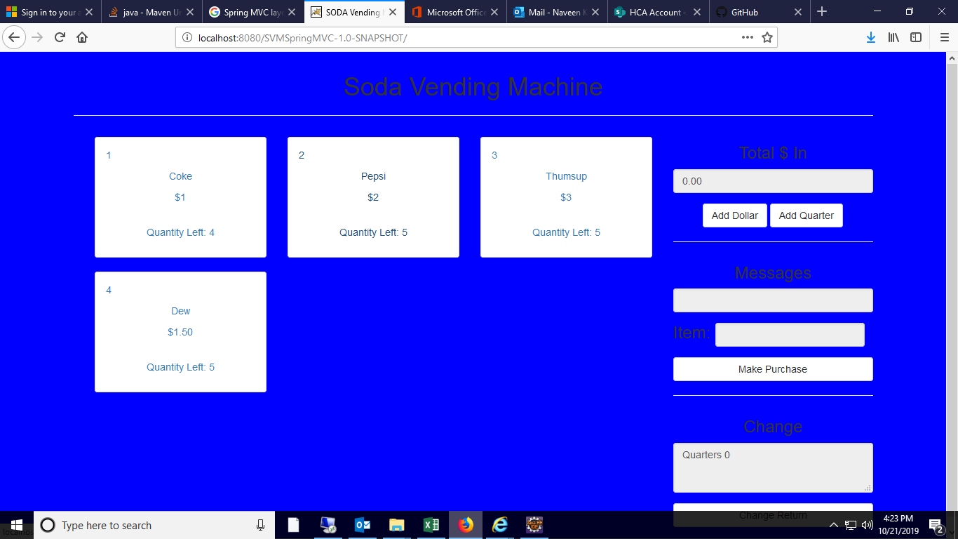

**Technical Requirements:**

1. Configured the Tomcat server and deployed the war file in the Tomcat Server.
2. The Values for all the items is passed using the Collections HashMap in the code.

**Architecture Design:**

The MVC pattern results in separating the different aspects of the application (input logic, business logic, and UI logic), while providing a loose coupling between these elements.

There are mainly three main categories: **MODEL, VIEW, and CONTROLLER**. Each of the layers contains objects related to the particular concern it represents.

* **The MODEL layer** handles all the DAO (Data Access Object) related information.It will contain the Implementation of service classes.
* **The VIEW layer** handles the frontend part which is used to display the webpage.In the application JSP files are used as view layer.
* **The CONTROLLER layer** is responsible for processing user requests and building an appropriate model and passes it to the view for rendering.

**Functionality of Vending Machine System:**

We are displaying list of items in vending machine from backend services and displays on UI with Item Name, Amount to Insert, Change to return,Message.

**Flow of Application:**

1. Each item is displayed using the Item id i.e. 1,2,3,4 along with the Item name and number of quantity left and price of the item.
2. Add the amount using the “ADD QUARTER”/”ADD Dollar”.
3. After selecting the Item and adding money click on “Make Purchase”. It will show the respective message.
4. If the respective amount is not present it will display with a error message.
5. At the end it will display the difference of amount to be return.
6. To reset the application we have to refresh the page.